SoTL Entry Points: Where Can I Start?
These prompts are designed to help you identify starting points for the Scholarship of Teaching and Learning (SoTL) in your own teaching context. Reflect on your curiosities, observations, beliefs, and commitments to uncover questions, gaps, or problems that might guide meaningful inquiry into student learning.

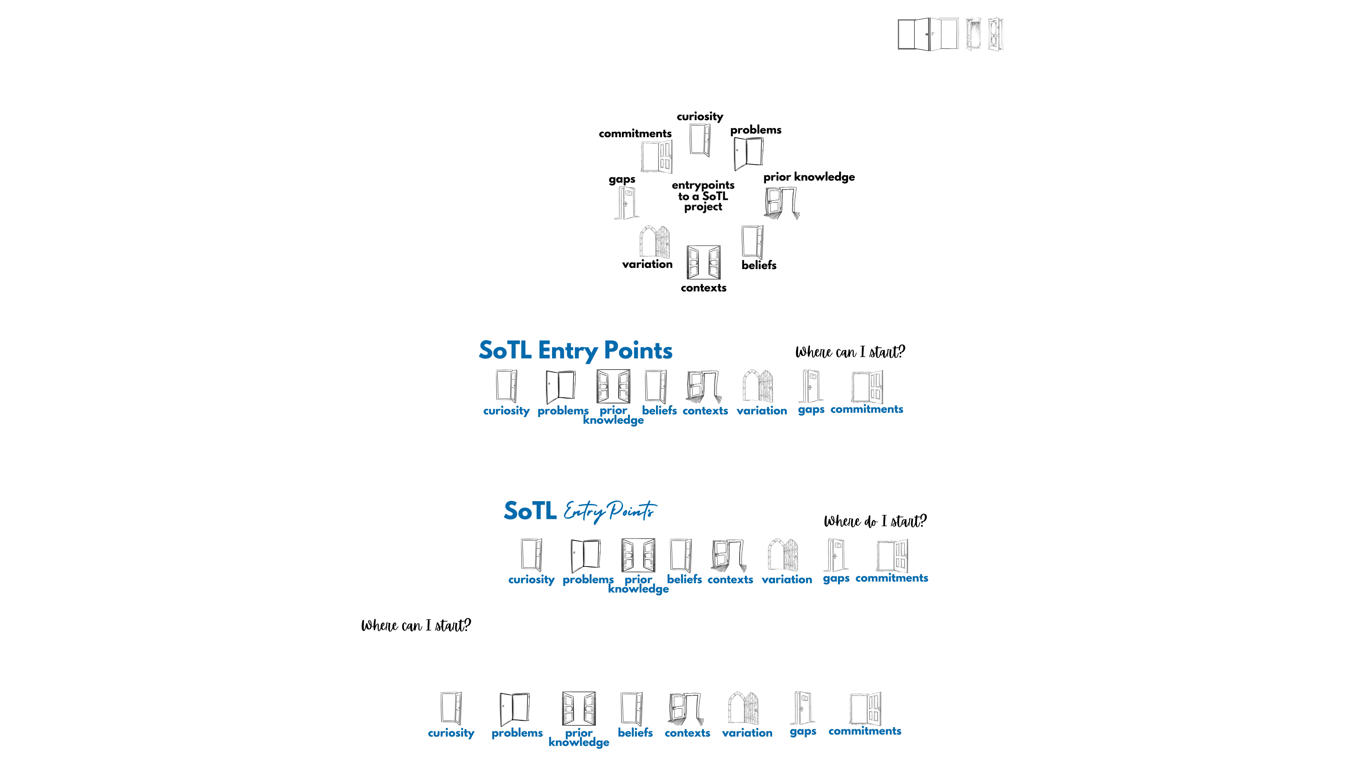
Following Your Curiosity
- What are you curious about as you think about your students, their learning, or their experiences as learners?
- What puzzles you when you teach a specific course, concept, or skill?
- What new ideas about teaching and learning have you encountered that have stuck with you?

Reframe a Problem
- What is a “problem” (Bass 1999) with your students’ learning that’s plagued you, puzzled you, piqued your interest, and/or pleased you? How is it a “problem”? When does it happen? How does it become visible to you, and what does it look like? What are its consequences?
- What is a problem, complexity, or phenomenon about students’ learning in your discipline that you and your colleagues keep returning to? How can that be explained or understood more deeply?

Surfacing Prior Knowledge
- What do you know about your students’ prior knowledge and beliefs about your course content?
- What about their beliefs about learning, your discipline, or themselves as learners?
- What strategies can you use to activate their prior knowledge? What strategies can they use? And how can you use that information to support learning in your course?
- Based on what students bring to your course, do you see patterns of struggle or success that might suggest lines of SoTL inquiry?

Probing a Belief
- How would you finish the sentences below?
  - Today’s students are ____.
  - Today’s students prefer ____.
  - I’ve noticed my students are/do ____.
  - My students learn by ______.
- Why do you believe each of these statements to be true?
- What does each of these beliefs lead you to do in your teaching?
- How might a different belief lead you to act (and teach) differently?

Exploring Your Context
- What aspects of your context are distinctive or seem particularly significant to you? How might you use those as entry points in your SoTL inquiry?
- Is something changing in your context that might be worth examining more closely?
- Are there SoTL inquiries that you find inspiring or challenging that you'd like to adapt to your context?

Considering Variations Among Your Students
- What groups of students (or even profiles of students) would you like to—or need to—learn more about as learners in your course?
- How might different students experience your courses (or specific activities in your courses) differently?
- What might you learn by inquiring into the study habits of students who tend to be successful in your course, or students who initially struggle and then succeed?

Filling a Gap
- Are you aware of any gaps in what’s currently known about teaching and learning—perhaps as described by something you’ve read or what you’ve noticed from a preliminary literature review? What interests you about this gap?
- Which gaps noted in the “Fill a Gap” section of chapter 3 speak to you, and how might you start to fill them?
- What underexplored perspectives, contexts, identities, and cultures do you or your students bring to teaching and learning that you could explore in a SoTL inquiry?
- Even if your SoTL inquiry follows a well-trod path, what is different about your or your students’ context or experiences that would offer new insights on a familiar topic?

Honoring Your Commitments
- What do you think the purpose of higher education is? Is it serving this purpose right now? How do (or might) your classes contribute to this purpose?
- What are you committed to as an educator and a person? What do you care about, deeply? How do (or might) you bring those values into your teaching, and how do (or might) your students experience these commitments?
- What commitments do you see in your students? How do (or might) you facilitate learning experiences that speak to these commitments?

In “The Scholarship of Teaching: What’s the Problem?” Randy Bass encourages us to approach “problems” in our teaching and in our students’ learning with an inquiry orientation, rather than with shame or in solitude. In our disciplinary research, he notes, we want to talk with colleagues about the interesting and vexing problems we encounter, but the same isn’t true about our teaching. Framing teaching and learning “problems” like research problems puts them “at the heart of the investigative process” (1999, 1).

