Nuanced What works?
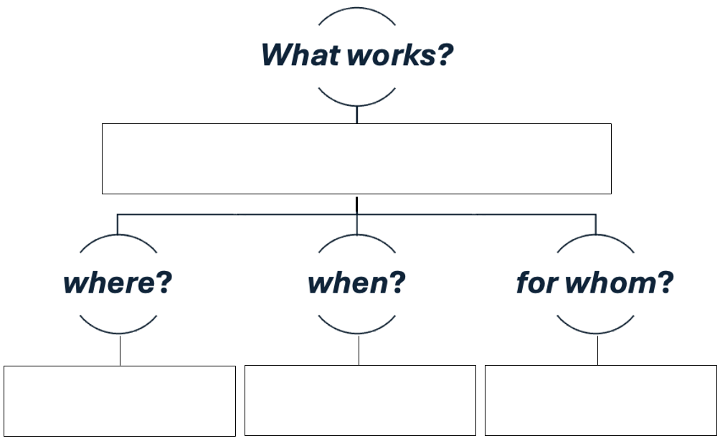
Use the graphic below to chart the components of a What works? SoTL question—whether it’s your own or one you’re reading or hearing about.

