Analyzing Some Definitions of SoTL
In chapter 1, we offer our simple definition of SoTL as “inquiry into teaching and learning for the purposes of improving teaching and learning in context and contributing to what we know about teaching and learning, in support of the broader aims of higher education.” We also acknowledge that “our definition is missing a lot of nuance,” so let’s consider some of those nuances.

A Handful of Definitions
Below are some more detailed definitions of SoTL. As you read a few or all of them, note any observations. Where’s the common ground, and where are the distinctions? How does each describe the components of SoTL? What emerges as a consensus among these five? You’ll chart them in the matrix in the next section.

A Visual Definition
In SoTL workshops, Nancy shares the visual definition below (Chick 2020) as a graphic organizer for participants’ guided notes. She developed this more complex definition of SoTL to address some common questions and misconceptions that have emerged over the years.

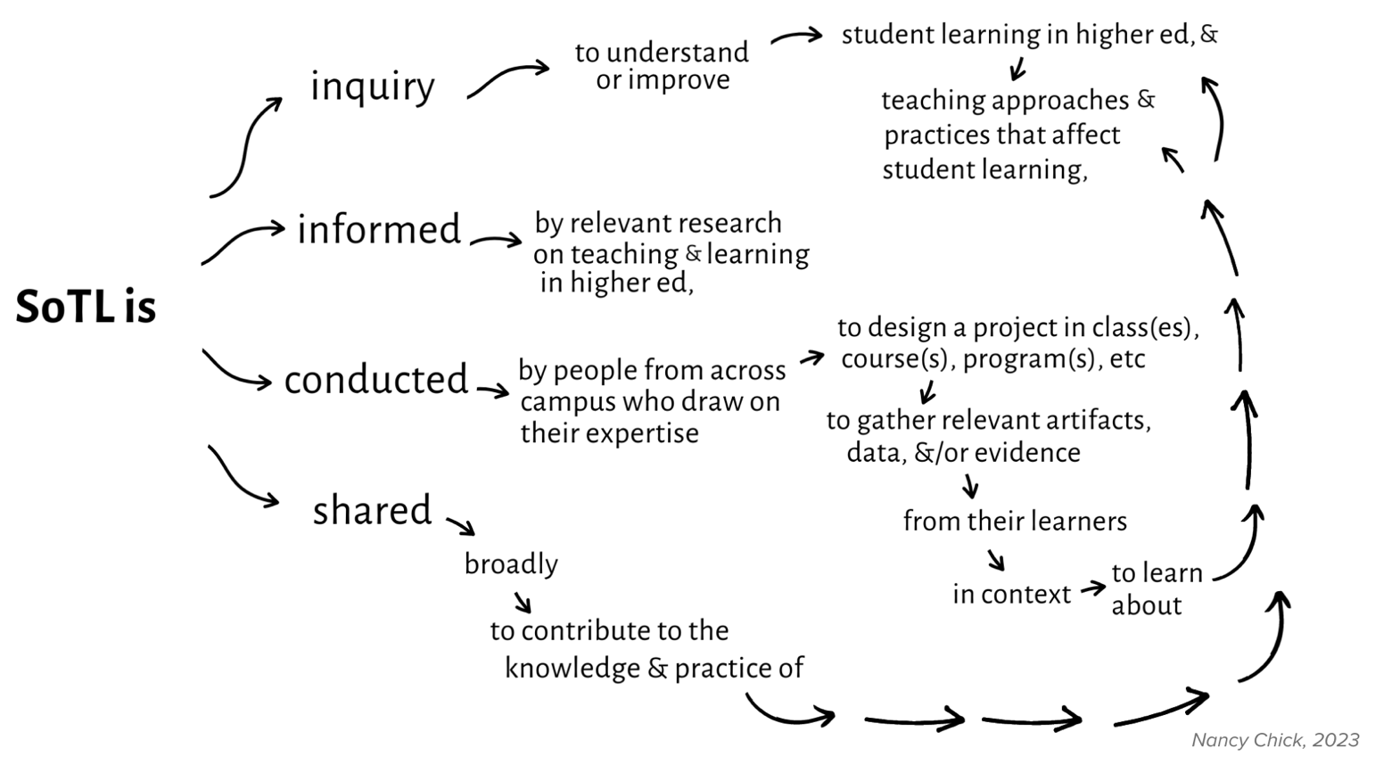

Foregrounding Student Learning
Whereas the visual definition above is meant to be more comprehensive, some emphasize a single characteristic as most important, such Keith Trigwell and Suzanne Shale’s “Student Learning and the Scholarship of Teaching and Learning” (2004). After reviewing some of the foundational definitions of SoTL, the authors develop their own to foreground student learning.

Principles of Good SoTL Practice
We can also better understand SoTL by looking at how it’s practiced. Peter’s “Principles of Good Practice in SoTL” (Felten 2013) offers five defining features of effective SoTL that practitioners often cite as foundational to their understanding.

Distinguishing SoTL from Scholarly Teaching
SoTL is commonly defined by distinguishing it from scholarly teaching, as in Michael K. Potter and Erika D.H. Kustra’s “The Relationship between Scholarly Teaching and SoTL: Models, Distinctions, and Clarifications” (2011).

Defining SoTL in Context
As you’ll see throughout The SoTL Guide, context matters in SoTL, which applies to individual SoTL projects as well as how SoTL is broadly understood. An example of the latter is found in Michael Anthony Samuel’s “Developing a Syntax for SOTL” (2017), which describes SoTL as it’s practiced in the southern hemisphere by—like Potter and Kustra—first distinguishing it from scholarly teaching and then emphasizing its explicit response to what’s happening in the world beyond the university.

Charting Your Analysis
Below is a matrix for you to chart your observations of these definitions. We’ve left the column headings blank, so you’re able to map your own observations, but if you need a place to start, here are some possibilities:
- Overlaps (points of agreements), Complements (outlying or unique points not reflected in other definitions), Contrasts (points of disagreement)
- Who (who practices SoTL), How (its approach and processes), Where (its context, scale), Why (its goals)
- Points of Consensus (what points do they all agree on, and what do they say specifically about each of these points?)
- Implications for My Practice (What components or steps will you want to apply, and what’s the specific guidance from each?)

Source | [Your Heading] | [Your Heading] | [Your Heading] | [Your Heading] | [Your Heading]
1. Chick’s Visual Definition

2. Trigwell and Shale’s Focused Definition

3. Felten’s Principles of Practice

4. Potter and Kustra’s Distinction

5. Samuel’s SoTL in the Southern Hemisphere

References
Chick, Nancy L. 2020. “A Visual Definition of SoTL.”

Felten, Peter. 2013. “Principles of Good Practice in SoTL.” Teaching & Learning Inquiry 1 (1): 121-25. https://doi.org/10.20343/teachlearninqu.1.1.121.

Potter, Michael K., and Erika D.H. Kustra. 2011. “The Relationship between Scholarly Teaching and SoTL: Models, Distinctions, and Clarifications.” International Journal for the Scholarship of Teaching and Learning 5(1): 1-18. https://doi.org/10.20429/ijsotl.2011.050123.

Samuel, Michael Anthony. 2017. “Developing a Syntax for SOTL.” Scholarship of Teaching and Learning in the South 1 (1): 19-38. https://doi.org/10.36615/sotls.v1i1.11.

Trigwell, Keith, and Suzanne Shale. 2004. “Student Learning and the Scholarship of Teaching and Learning.” Studies in Higher Education 29 (4): 523-536. https://doi.org/10.1080/0307507042000236407.

